**SpotImage documentation - background images used in demo_20180711**

I cropped three 300 px by 300 px fields of view from the cell culture image1 and three from the tissue image.2 The background images shown here are produced by generating a SpotImage from each crop (setting num_spots = 0).

1. MAX_C3-ISP_FixationTest_293T_PFA_20180601_1_MMStack_Pos0.ome.tif
2. MAX_ISP_smFISH_msLung_60x_1-47_20180319_1_pos0.tif

I aimed to select FOVs that represent a variety of features.

Cell Culture Background Images:

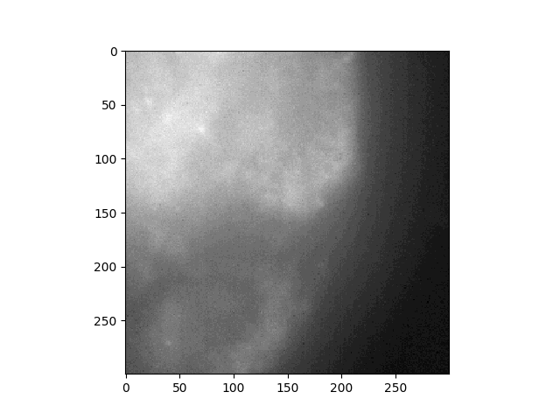

*MAX_C3-ISP_300_1.png*

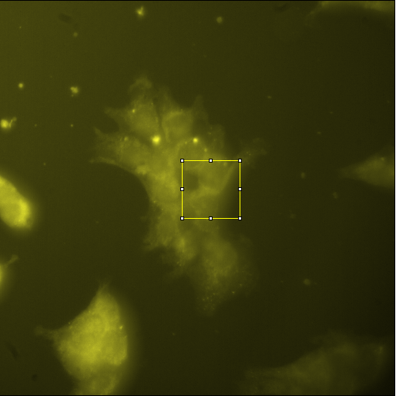

*Crop location*

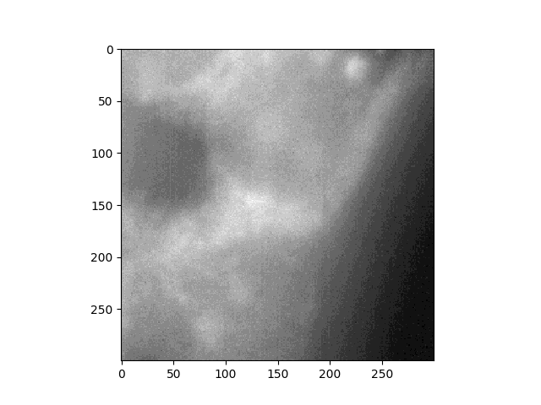

*MAX_C3-ISP_300_2.png*

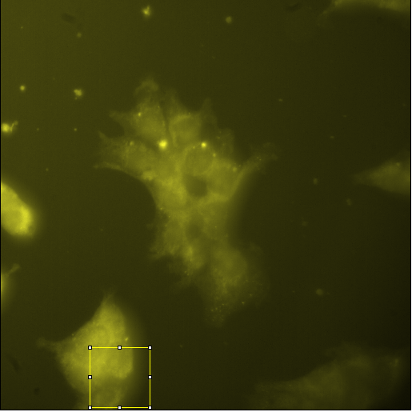

*Crop location*

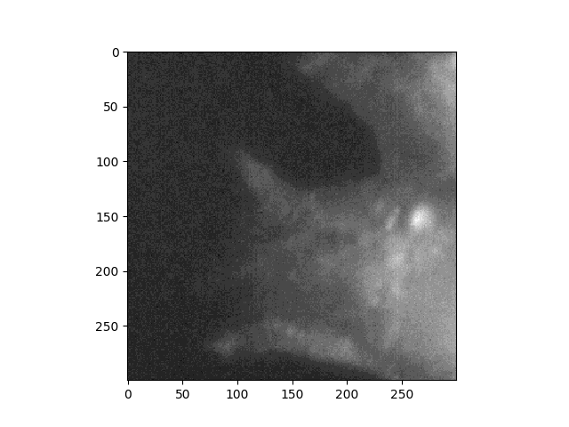

*MAX_C3-ISP_300_3.png*

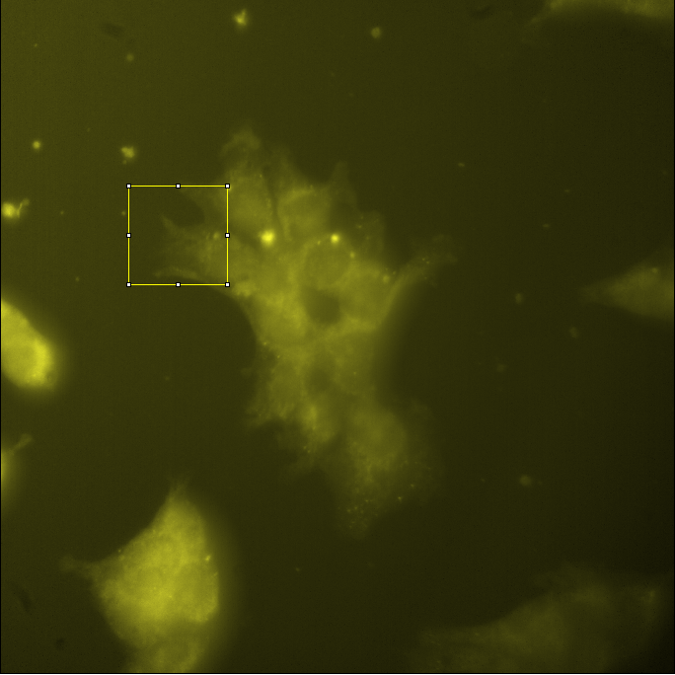

*Crop location*

Tissue Culture Background Images:

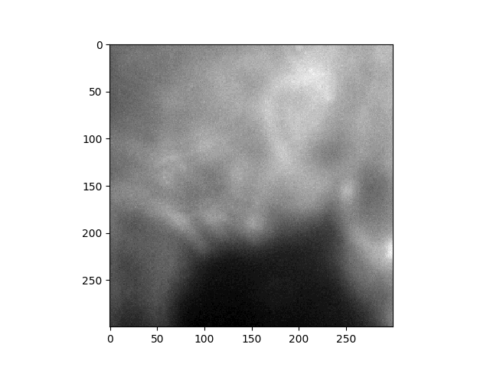

*MAX_ISP_300_1.png*

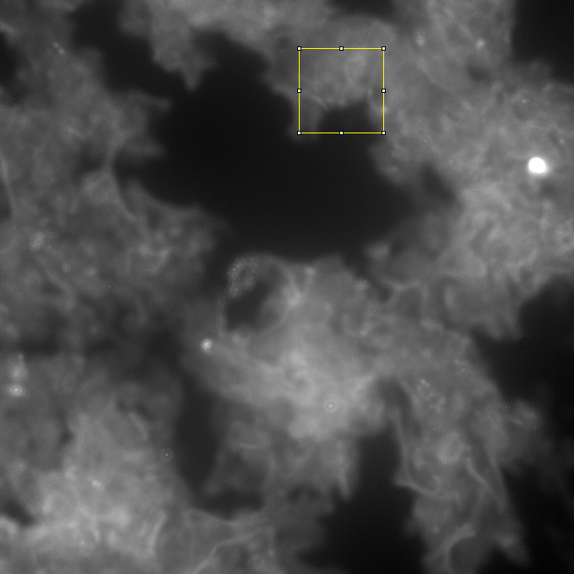

*Crop location*

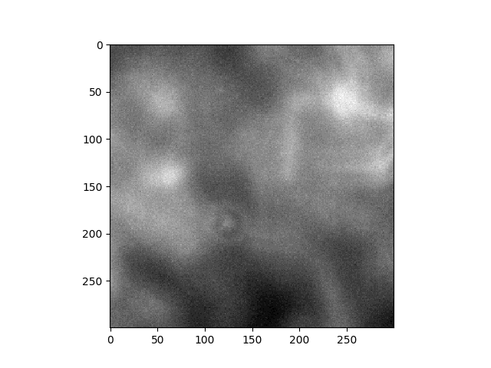

*MAX_ISP_300_2.png*

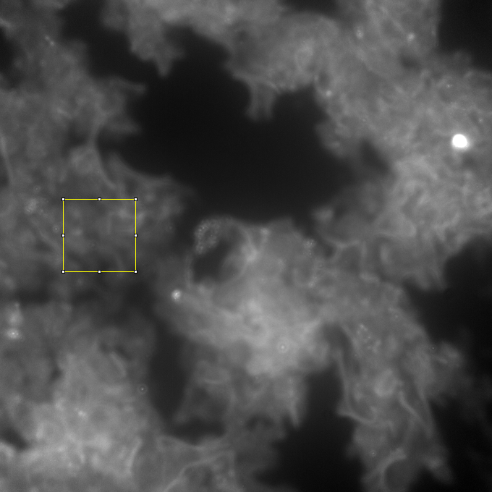

*Crop location*

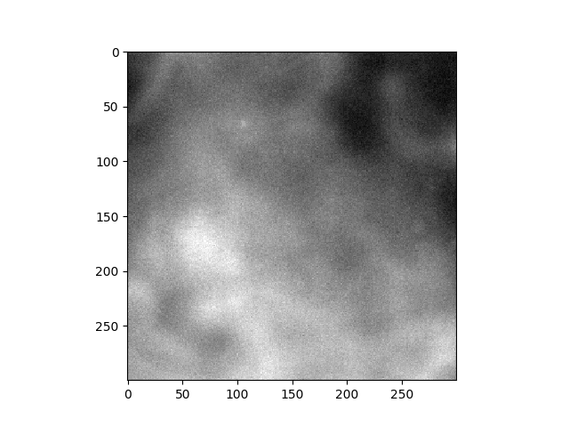

*MAX_ISP_300_3.png*

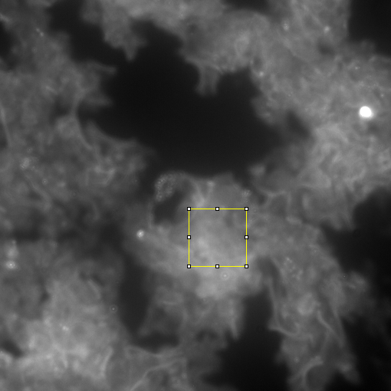

*Crop location*